Department of Information Technology
Faculty of Computing
The Islamia University of Bahawalpur



Software Requirement Specifications

AI-Based Facial Emotion Recognition System

Submitted by
Abdullah Waqar
S23BINFT1M01138

Submitted to
Mr Munawar Ahmad

Summary
This project will develop an AI-powered facial emotion recognition system that will detect human emotions from facial images in real time. A mobile app built with Flutter will allow users to capture faces using the phone camera and send images to a backend for analysis. The backend, implemented with Flask or FastAPI, will communicate with a CNN model in Python using OpenCV and TensorFlow. The model will be trained on datasets like FER2013 or CK+ to recognize emotions such as happiness, sadness, anger, and surprise. After processing, the system will return the predicted emotion and confidence score, which the app will display to the user.

Table of Contents

1. Introduction 4
1.1. Purpose 4
1.2. Scope 5
1.3. Product Perspective 5
1.4. User Characteristics 5
1.5. Proposed Technologies 6

2. Requirements 6
2.1. Function Requirements 6
2.2. Non-Functional Requirements 8

3. Use Cases and Flow of Processes 9
4. UML Diagram of Workflow 12
5. References 13

- Introduction
The AI-Based Facial Emotion Recognition System is a mobile-centric application designed to identify human emotions from facial expressions in real time using deep learning techniques. The system bridges the gap between human emotional cues and machine interpretation by leveraging computer vision and convolutional neural networks (CNNs).
The architecture is composed of three primary layers:
- Frontend (Flutter Mobile App): Handles user interaction and camera input
- Backend API (FastAPI/Flask): Manages communication and processing requests
- AI Model (TensorFlow/Keras): Performs emotion classification
The application captures facial images via the smartphone camera, sends them to the backend server, and receives predictions such as:
- Happy 😊
- Sad 😢
- Angry 😠
- Surprise 😲
- Neutral 😐
Each prediction is accompanied by a confidence score, allowing users to understand how certain the model is about its output.
  - Purpose
The purpose of this project is to develop a real-time, AI-powered mobile system that can:
- Analyze facial expressions and infer emotional states
- Provide immediate feedback through an intuitive interface
- Demonstrate the integration of AI models into real-world mobile applications
This project also serves as a practical implementation of computer vision and deep learning concepts, showcasing how theoretical models can be deployed into production-like environments.

  - Scope
- Capture facial images using the mobile device camera
- Detect faces within the image using OpenCV
- Preprocess images to match model input requirements
- Predict emotions using a trained CNN model
- Display results (emotion + confidence score) within the mobile app

  - Product Perspective
This system behaves like a digital interpreter of human expressions It observes a face, decodes subtle muscle patterns, and translates them into emotions the machine understands.

System Flow:
Flutter App → Camera Input → API Request → Backend Processing → CNN Model → Emotion Prediction → UI Display

Key Components:
- Mobile Layer: Captures images and displays results
- API Layer: Acts as a bridge between app and model
- AI Layer: Processes images and generates predictions

  - User Characteristics
The application is designed for a broad audience, including:
- Students and researchers exploring AI
- Developers demonstrating machine learning applications
- General users interested in interactive AI features
The interface will be designed to be minimal, intuitive, and responsive, ensuring ease of use for all users.
  - Proposed Technologies

Layers | Technology
Mobile App | Flutter (Dart)
Backend API | FastAPI / Flask
AI Model | TensorFlow / Keras
Image Processing | OpenCV
Dataset | FER2013 / CK+
Communication | REST API (HTTP/HTTPs)

- Requirements
  - Function Requirements
The functional requirements of the project define the essential features and operations that the system must perform to achieve its objectives. These requirements focus on the key functions.

    - Capture Image

- Id: FR001
- Title: Capture Image
- Description: The system shall allow users to capture facial images using the mobile device camera in real time.

    - Send Image to Backend

- Id: FR002
- Title: Send Image to Backend
- Description: The application shall convert the captured image into a suitable format (e.g., Base64 or multipart file) and send it to the backend API.

    - Face Detection

- Id: FR003
- Title: Face Detection
- Description: The system shall classify the user query and generate an appropriate response using the trained ML model.

    - Image Preprocessing

- Id: FR004
- Title: Image Preprocessing
- Description: The system shall preprocess detected face regions by:
- Resizing to model input size (e.g., 48x48)
- Converting to grayscale
- Normalizing pixel values

    - Emotion Classification

- Id: FR005
- Title: Emotion Classification
- Description: The system shall classify the processed facial image into predefined emotion categories using a trained CNN model.

    - Return Prediction

- Id: FR006
- Title: Return Prediction
- Description: The backend shall return:
- Predicted emotion label
- Confidence score

    - Display Results

- Id: FR006
- Title: Display Results
- Description: The Flutter application shall display:
- Emotion label
- Confidence percentage
- Optional visual indicators (icons/emojis)

    - Real-Time Detection

- Id: FR006
- Title: Real-Time Detection
- Description: The system may continuously process video frames for real-time emotion detection.

  - Non-Functional Requirements
Non-functional requirements define the overall qualities and constraints of the system, focusing on how the system performs rather than what it performs. These requirements ensure the following:

- Performance: Response time should be under 2 seconds per request
- Scalability: Backend should support concurrent requests.
- Accuracy: Model should achieve at least ~70% accuracy on benchmark datasets
- Usability: Clean, intuitive UI & Minimal interaction steps
- Maintainability: Modular structure for easy updates (model, API, UI independent)
- Security & Privacy: Secure API communication using HTTPS & No unauthorized data storage
- Reliability: System should operate consistently with minimal crashes

- Use Cases and Flow of Processes

Use cases describe how users interact with a system to achieve specific goals, translating functional requirements into practical scenarios. In this project, the primary actors are end-users. These use cases help the development team understand critical processes and allow stakeholders to visualize the system’s operation in real-world scenarios.

  - Capture and Analyze Emotion

ID | UC001
Name | Capture and Analyze Emotion
Requirement(s) | FR001, FR002, FR006, FR007
Actor(s) | User, System
Precondition | The user has installed the mobile application  The device camera is functional and permission is granted  Internet connection is available
Postcondition | The captured image is successfully sent to the backend  Emotion prediction is received and displayed to the user
Basic Flow | - The user opens the mobile application  - The system initializes and displays the camera preview  - The user captures an image using the camera  - The application converts the image into a suitable format  - The image is sent to the backend API  - The backend processes the image and generates a prediction  - The prediction is returned to the mobile application  - The application displays the detected emotion and confidence score

  - Process Image and Predict Emotion

ID | UC002
Name | Process Image and Predict Emotion
Requirement(s) | FR003, FR004, FR005
Actor(s) | System
Precondition | The backend has received a valid image from the mobile application
Postcondition | The system generates an emotion prediction with confidence score
Basic Flow | - The backend receives the image from the API request  - The system detects face(s) in the image using OpenCV  - The detected face region is extracted  - The image is preprocessed (resized, grayscale, normalized)  - The processed image is passed to the CNN model  - The model analyzes facial features  - The system predicts the emotion category  - A confidence score is calculated  - The prediction result is prepared for response

  - Send Prediction Response

ID | UC003
Name | Send Prediction Response
Requirement(s) | FR006
Actor(s) | System
Precondition | The emotion prediction has been successfully generated
Postcondition | The prediction is sent back to the mobile application
Basic Flow | - The backend formats the prediction result into JSON  - The response includes emotion label and confidence score  - The backend sends the response via HTTP  - The mobile application receives the response

  - Display Emotion Result

ID | UC004
Name | Display Emotion Result
Requirement(s) | FR007
Actor(s) | System
Precondition | The mobile application has received prediction data from backend
Postcondition | The user sees the emotion result clearly on the screen
Basic Flow | - The application parses the JSON response  - The emotion label is extracted  - The confidence score is calculated/displayed as percentage  - The UI updates dynamically  - The emotion is displayed using text and/or emoji  - The user can choose to capture another image

  - Continuous Real-Time Emotion Detection

ID | UC005
Name | Continuous Real-Time Emotion Detection
Requirement(s) | FR008
Actor(s) | USer, System
Precondition | The user enables real-time detection mode  Camera stream is active  Stable internet connection is available
Postcondition | Emotions are continuously detected and updated in real time
Basic Flow | - The user activates real-time detection mode  - The camera continuously captures video frames  - Frames are periodically sent to the backend  - Each frame is processed for face detection and emotion prediction  - Results are returned in near real-time  - The UI updates dynamically with changing emotions  - The process continues until the user stops detection

- UML Diagram of Workflow
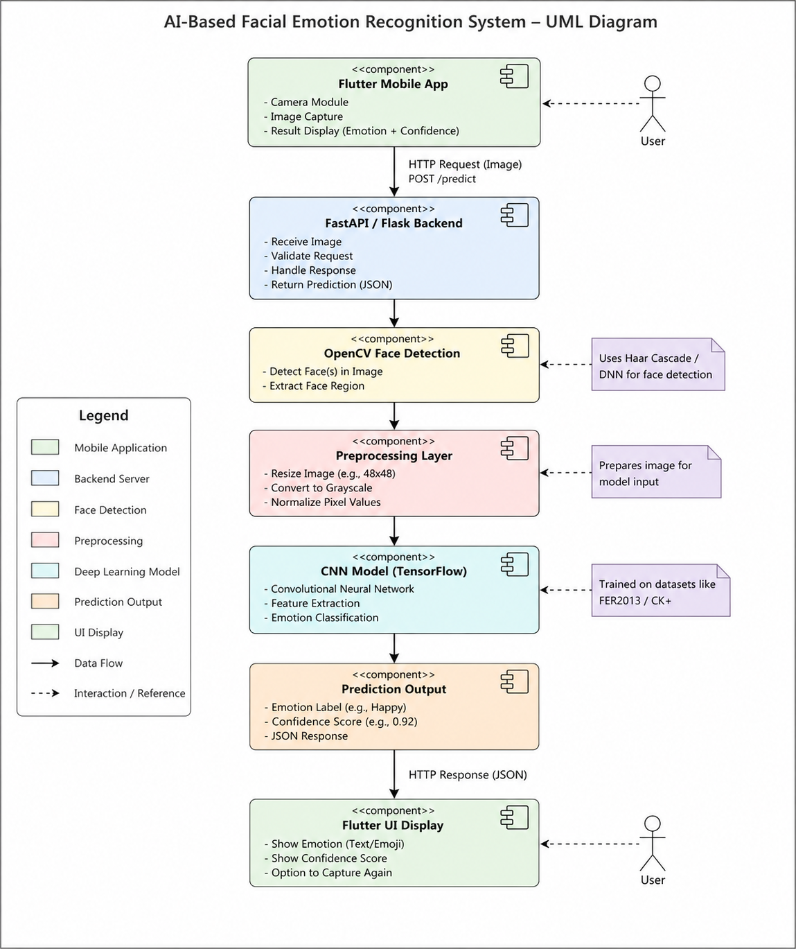
UML diagram of Entire System

- References
- Flutter Official Documentation : https://docs.flutter.dev/
- Abdullah Waqar, “AI based facial emotion recognition system,” GitHub Repository. https://github.com/Abdullah01-Flutter-Develpor/face-emotion-recognition-ai
- Python Software Foundation, “Python Official Documentation,” Python Web Tool. https://docs.python.org/3/

